Design Specification for a RFID Card Game

Specification

System Description
This specification describes and defines the basic requirements for a wearable digital card-gaming device. The device will house 1 or more RFID readers that would take data from placed RFID cards and use them in a game of the user’s choosing. The user would be able to wirelessly communicate with other players in possession of the device for multiplayer mode.

Specification of External Environment
The device is to be operated in an indoor/outdoor environment with relative humidity consistent with desert and tropical environments. It must be durable enough to withstand various types of users, especially small children. The unit is to be portable and battery operated.
Temperature Range 0-60C (32-140F)
Humidity 30-60% non-condensing

System Input and Output Specification

System Inputs
The system shall support the measurement of the following kinds of signals:
- Frequency in the standard 13.56 MHz range for close range RFID signals
- It will follow protocols from ISO 15693 for RFIDs

The system will also accept user input from a keypad that will determine which mode to set the game in: single player, multiplayer, and card building. It will also allow the user to navigate the menu screens and select their next move.

If the system is in multiplayer mode, it must receive game data from the device of another player and modify the user’s game state based on that data. The shared data consists of players’ scores, current cards on the field, etc.

System Outputs
The system shall display information about the current game state and the reading from the RFID signal on an LCD display

When the system is in multiplayer mode, data must be sent wirelessly to another device. This data consists of players’ scores, current cards on the field, etc.

User Interface
The user shall be able to select the following using buttons and switches on the front panel of the instrument:
Mode:
Single Player
Multiplayer
Card Building
Card Reader:

Power ON/OFF
Reset
Game mode can be selected through a menu screen on the LCD display – the user will be able to navigate the menu with a keypad. Similar to a gaming device, the power will be controlled by a switch and reset will be a push button. Game output will be displayed on an LCD display. Such a display shall be readable from several angles.
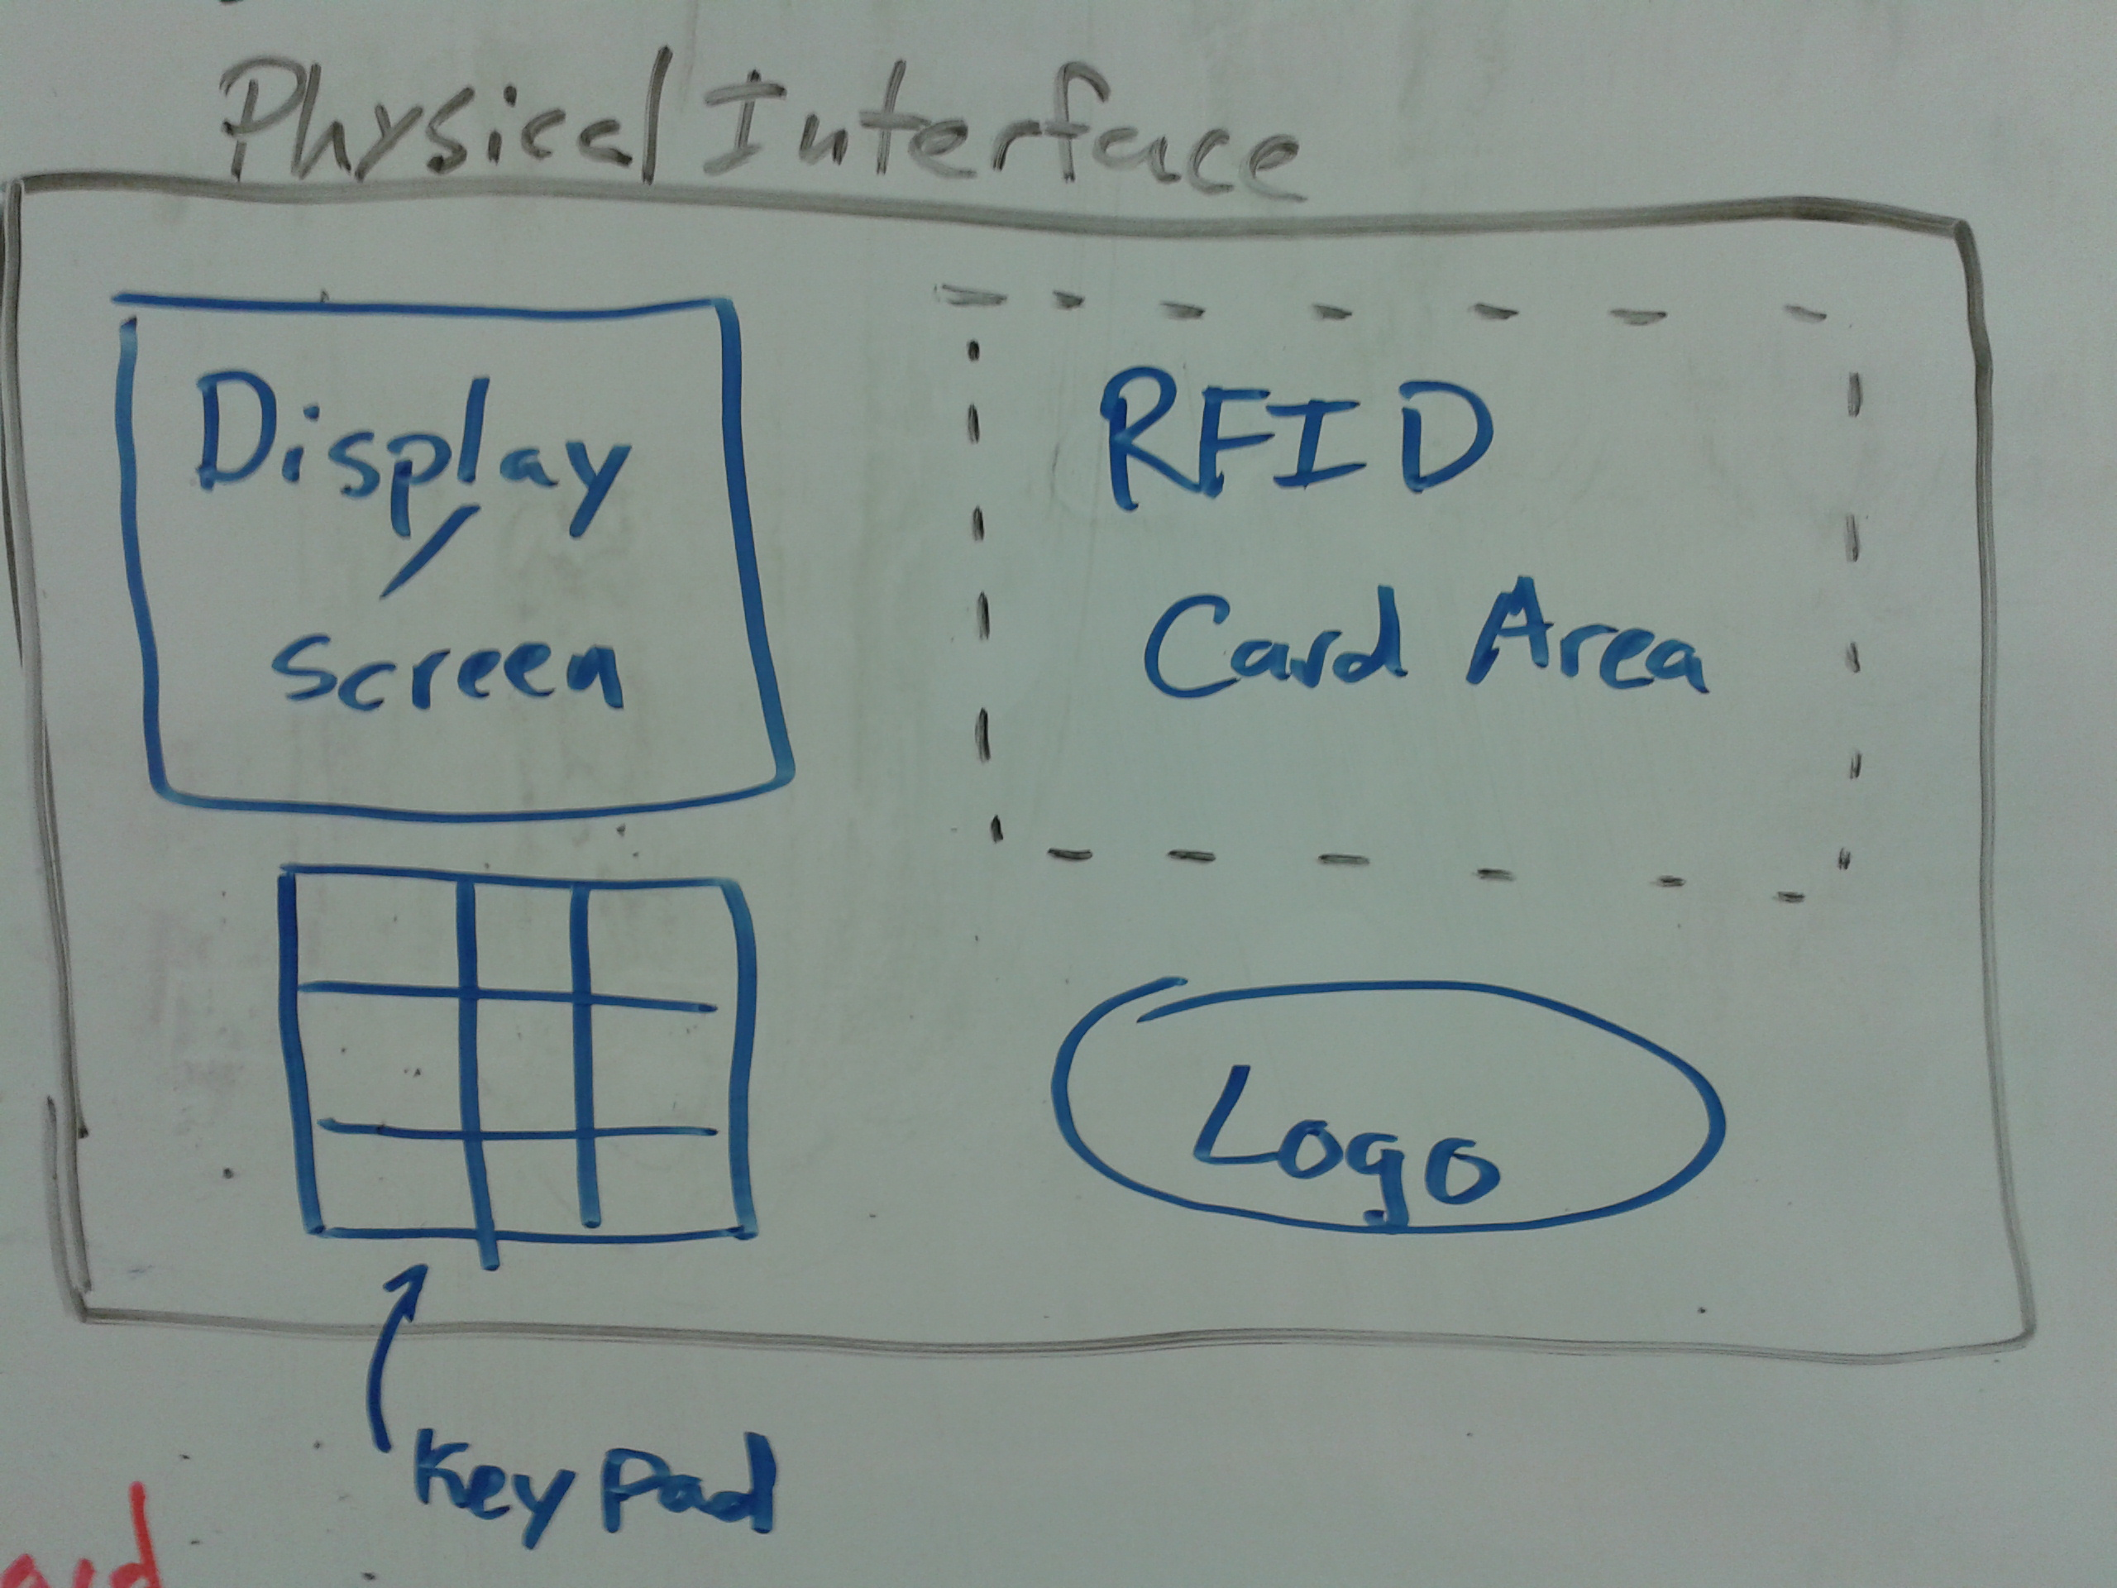
Simple drawing of the front panel

System Functional Specification

A user will be provided with a deck of RFID cards that contain data about whatever game the user wants to play. These cards would be used in the RFID reading device that would be worn by the user on their arm. First, the user must choose using the keypad what game mode they would like to play: singleplayer, multiplayer, or card building. In all three modes, the user will be instructed by the programmed game to place a card in the RFID reading area to interact with the game and control events. In multiplayer mode the user would have to find the other user they would like to play with and connect to their game using the wireless features of the system. In card building mode, the user would be able to enter data via the keypad to program their own data onto whichever RFID card they choose.

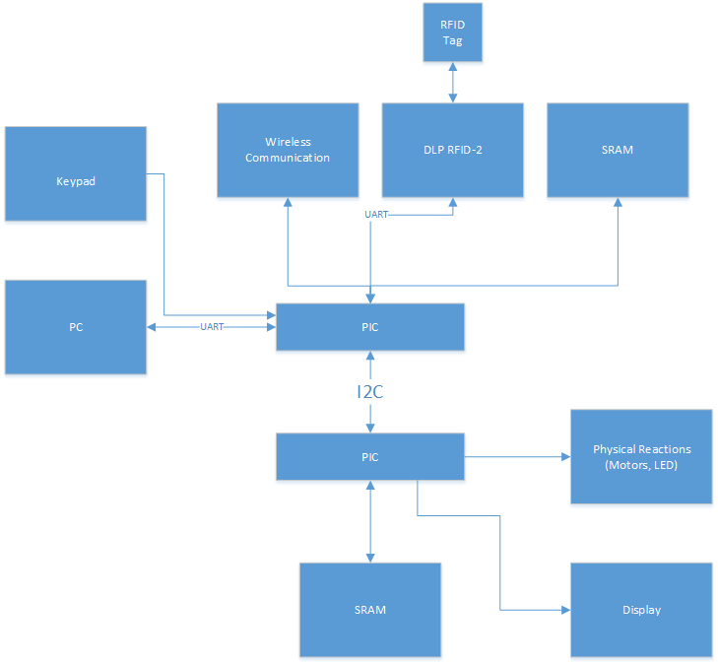

The block diagram above illustrates the RFID scanner system. The upper half of the I2C handles user input from the PC, keypad, and wireless communication with RFID tags. Though not shown, there is a MAX232 connection between the PC and the PIC. For testing purposes, the systems allows a PC connection at 9600 baud.

The bottom half of the I2C outputs data to the user through the display and physical reactions. In both sections, the PICs access the SRAM for the card database.

Operating Specifications
The system shall operate in a standard commercial or household environment
Temperature Range 0-60C (32-140F)
Humidity 30-60% non-condensing
Power 5 VDC

Reliability and Safety Specification
The RFID scanner shall comply with the following safety standards
UL: None
FCC Part 15, subparts A, C for Low Power Devices
ISO 18000-3 (RFID), 18092(EMCA-340 ), 21481(ECMA-352), 14443

The MTBF will be a minimum of 1,000 hours

